Objective: Learn basic SQL commands using MySQL.
Task: Create a database named college_db and a table named students.

Create a database named college_db.
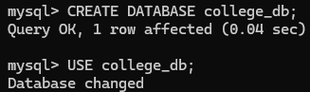
Create a table named students with the following columns:
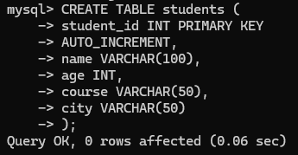

Insert at least 5 student records into the table with different names, ages, courses, and
cities.
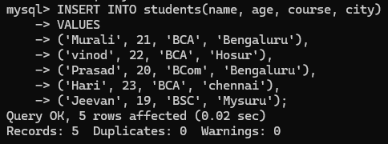

1. Display all student records.
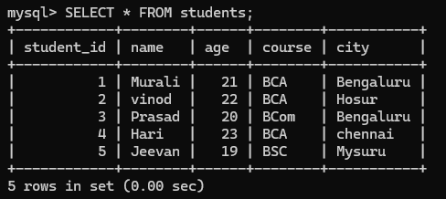

2. Display only the student names and courses.
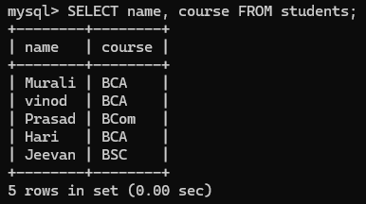

3. Find students whose age is greater than 20.
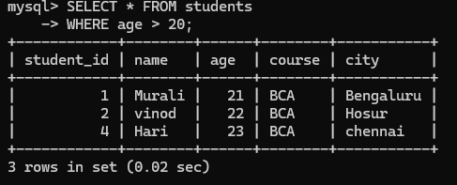

4. Find students who belong to Bengaluru.
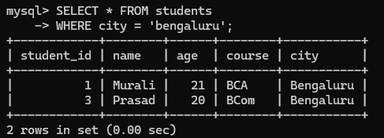

5. Display students studying BCA.
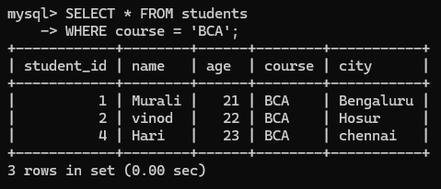

6. Display all students in ascending order of age.
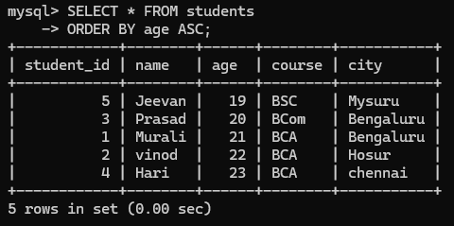

7. Update one student's city.
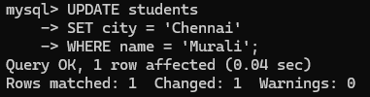
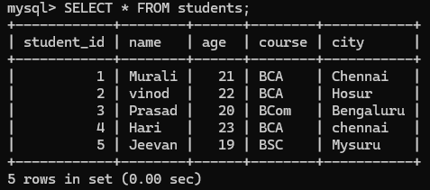

8. Count the total number of students.
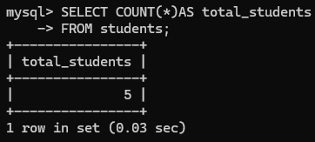

9. Delete one student record using their student ID.
